Manual Picto-Selector for Large Networks
Contents
Manual Picto-Selector for Large Networks 1
Used terms and their descriptions 1
Problem description 2
Users and sheets 2
Favorites 2
Several solutions 2
Using Windows username or using environment variable 2
Using Picto-Selector as office application 4
Activating large network solutions 5

Used terms and their descriptions
Picto-Selector | The software created by Martijn van der Kooij which contains the symbol database and the pictosheets
Organization | The Organization or institution that wants to Picto-Selector for their employees
Users | Employees using picto selector to create pictosheets for their clients.
Clients | The customers or clients of the organization. This involves parents, children and other people receiving care
Pictosheet(s) | The visuals created in Picto-Selector

Problem description

Users and sheets
Picto-Selector has a simple user management system. However for large organizations with many employees it is too much effort to create a Picto-Selector user for all employees. The list with users becomes too big to be manageable.
Another issue is that large organizations want to restrict the access of the material to employees working directly with their clients. Often only a few employees are allowed to access the information of a client.

Favorites
Each employee wants his own list of favorites.

Several solutions
There are several solutions implemented to use Picto-Selector in large organizations. We will first describe a few possible solutions.

Using Windows username or using environment variable
Use the Windows logon name or an environment variable to add an extra user layer in the pictosheet list. The Picto-Selector users become groups and employees logon into a group.
In the pictosheet list the Windows logon name is used and only sheets created by the current Windows logon name and without a name will be visible.
The group right “Do not use the Windows logon name” is available to ignore the Windows Logon name for a group like it always does for the Administrator group.
Example of the pictosheet list of a normal group Logopedists and Windows Logon name Martijn:
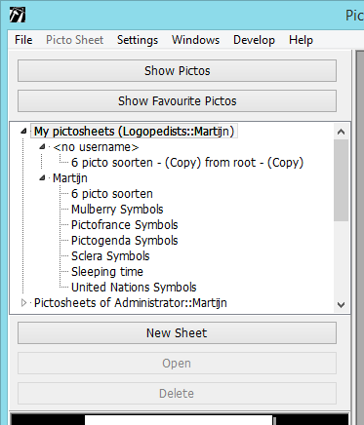
As a normal group only the owned sheets can be changed. When editing a pictosheet without Windows Logon user a copy will be made when saving the sheet.

Example of the picto sheetlist of the group administrators:
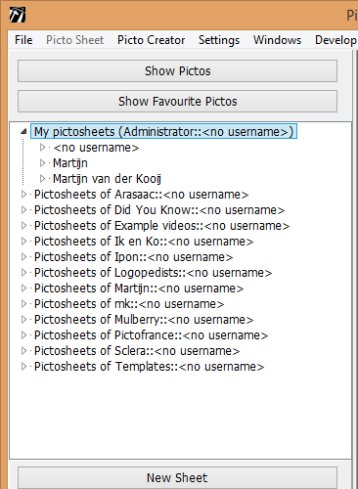
As administrator all Windows Logon users are made visible and all pictosheets can be edited without changing ownership.
It is also possible to use an Environment variable “PICTOUSER” to set the logon name.
Favorites are stored for each Windows Logon name.
This solution is useful when you have a lot of employees who do not have the need to share their work with colleagues for clients.

Using Picto-Selector as office application
Disable saving pictosheets to the database and show options to save the pictosheets to the file system. Or open a pictosheet from a selectable file location. Pictosheets are stored as .pszip files containing 1 sheet. Picto-Selector is started when a Windows user performs a doubleclick on a .pszip file.
When opening or importing pictosheets they are never saved to the database unless you log on as Administrator or with a user that has a special “Allow saving to database” right.
Opened pictosheets are shown in the list and it is easy to switch between them. When closing the pictosheet editor (for instance when the application is exited) all changed pictosheets will be saved with the name they had when opened. Newly created sheets can be saved to a selected location.
Example of the picto sheetlist when in Office Application mode:
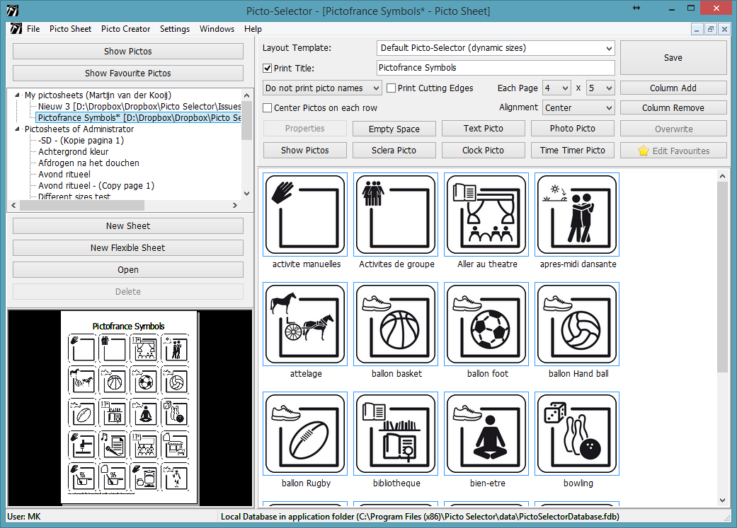

Favorites are stored for each Windows Logon name.
This solution is useful when you have a lot of employees who need to share their work with colleagues because they work for the same clients.

Activating large network solutions
You are only allowed to use this when you have a service agreement with MC van der Kooij. In return you are allowed to use those solutions in your organization.
Activation of those options (they are not visible by default) is possible by starting Picto-Selector with the command line option: -largenetwork
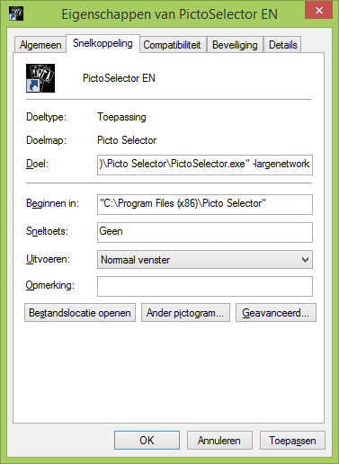
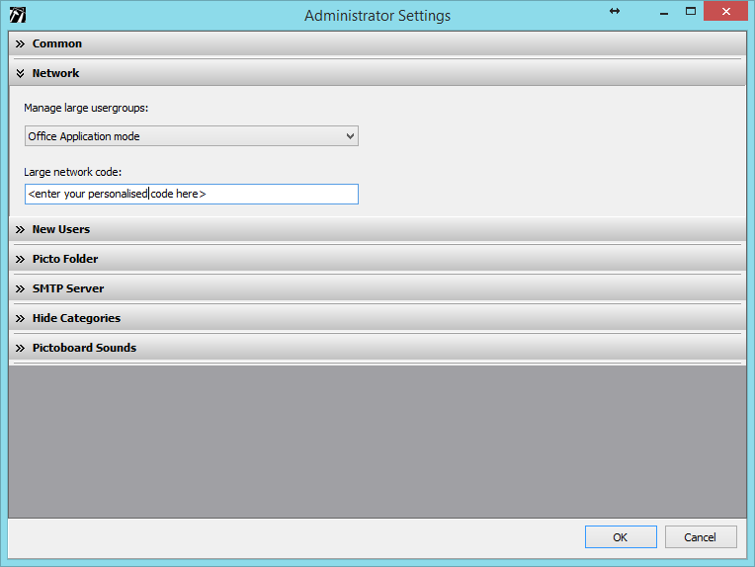

When started with this command and logging in as Administrator you can use the “Administrator settings” > “Network” to select one of those options:
- No (default)
- Windows Login username
- Environment variable "PICTOUSER"
- Office Application mode
You need to insert a large network code to enable the option. You can request a code by MC van der Kooij and is provided to organizations with a service license agreement.

